Encryption and Decryption Output
TEST 1,2,3
The developed Python program successfully performed both encryption and decryption using the Caesar Cipher. Different test cases were executed to verify the program, and the decrypted output matched the original input, confirming the correctness of the implementation.
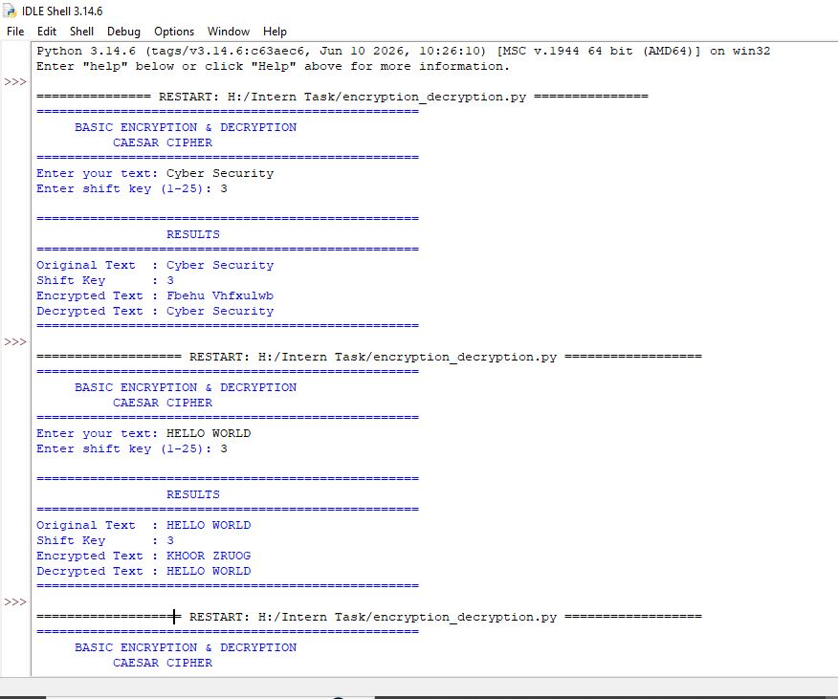
Implementation Results

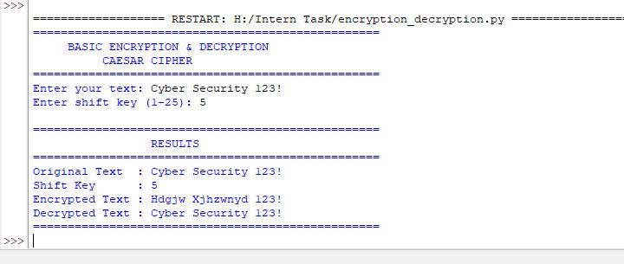

Snapshot : Successful execution of the Caesar Cipher encryption and decryption process.

